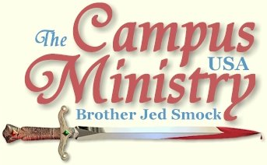
brojed@aol.com
brojed.org
573-999-0347
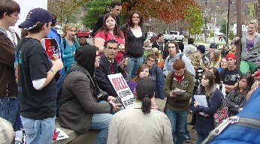

Note From Sister Cindy: My wonderful husband was home twice this week and both times it was less than a 24-hour period. He is really on the move and it inspires the girls and me. He should be back home tomorrow (Monday) and the weather looks good for preaching in Missouri next week. We did incur some extra expenses in the last two weeks. We had to buy a new set of tires for the van and Bro. Jed's car needs about $400 worth of work. Thanks for praying for that, and giving if you can.

Indiana State University, November 2, 2009
Yesterday afternoon, Cindy and I drove 6 hours home from Louisville. I got up early this morning for a 5 hour drive to Terre Haute, IN. I just missed the noon break. Larry F. and two of his friends greeted me on my arrival at Dede Plaza. The loud and large water fountain was still running which is in the midst of the Plaza. I had hoped by this time of year that it would be shut down. The weather was about 60 and partly sunny.
I started preaching at 12:45 shortly thereafter the fountain shut down for about 20 minutes, which gave me time to gather a crowd which maintained at 20-25 for most of the afternoon. A heavy set crude homosexual was the first to confront me. He spoke of his perversion in very gross terms. Shortly thereafter a gay blade, Eric, whom I remember from last year, arrived wearing a black cape. Eric stayed around for most of the afternoon wanting to be the center of attention. Walter, a long haired skeptic, whom I recalled from last year, spent much of the afternoon listening and interacting. Last year I had debated with him concerning the Satanic Bible. Walter has an evangelical background and is an outwardly pleasant fellow.
I wore my sandwich board sign since I suspected that I might have difficulty getting the students attention with the noisy fountain. One student accused me saying, “You are a hypocrite because you have socialism listed on your sign and you are socializing with people out here.” I love my alma mater, Indiana State; but the school never did attract the best and the brightest.
I bantered with the students today more than usual. The main issue was sodomy. But I also had lengthy discussion on holiness, especially with one young man who claimed to be a Christian. He challenged me on my claim to be living holy. I offered him a copy of Walking in the Spirit. He said, “No thanks, I am good.”
I answered, “You are not good until you reckon yourself to be dead to sin and alive unto God.” Those that are alive unto sin are dead onto God.
I learned from Larry F. that Dan Phillips, who used to preach with my old associate Max Lynch, is preaching again after a layoff of several years. Students tagged him Disco Dan because he did a shuffle with his feet as he preached.
I stopped preaching at 4:50.
SIGNS WORK
Indiana University, November 3, 2009
As I waited to preach, my mind rushed back 49 years when I was a freshman frat boy at IU; already I was a drunkard; and I had objectified women as sexual objects before I even enrolled. I thought what a shameful life I lived in for a year and a half on this campus. I wasted the money my parents sacrificed to provide by consuming booze when I should have been concentrating on studying. I wondered how I could I have been so stupid, selfish and wicked. I do not remember anyone on campus urging me to consider Christianity. Nor were there any open air campus preachers in those days. Today, I suspect few students will graduate from IU without being confronted by a campus preacher.
William Bennet, conservative talk show host and Secretary of Education under Reagan has suggested that students usually do not have the maturity to go from high school to college. He is an advocate of military service, then college. I strongly agree. If not the military, then one should consider working for a few years and then go unto college. Or better yet get involved in some short time missions program, like YWAM. After these experiences, youth are more likely to have the maturity to handle the temptations.
IU has huge class breaks. At about 12:20 hundreds of students started passing. I only gathered 8-12 people and these numbers remained constant for the next three hours. Although the numbers were small, the students were attentive and not argumentative. I noticed looks of conviction are a number of faces. Since several in the group were professing Christians, I emphasized holiness and the necessity of taking a bold and public stand against sin and for righteousness. Usually these subjects bring objections from professing Christians. But this group listened mostly without opposition and for the most part politely.
By 3:15 everyone left. One girl who had been listening the whole time said as she departed, “Thanks for coming. I learned a lot.”
Another class was starting to pass; so I quickly returned to my car which was parked within a hundred feet to get by sandwich board sign which lists, fornicators, drunkards, sodomites, dope fiends, feminists, liars, socialists and the like. What a difference such signs can make in gaining attention. Within 20 minutes I had a crowd of 100.
I preached until 5:50 PM. One of the many that objected to my sign suggested, “You have nouns listed on your sign; it would be less offensive if you listed the sins as verbs.”
“I want to make my message as personal as possible. I want the students to think that I am preaching to them, not just speaking of sin in the abstract,” I replied.
It was almost as if I had two meetings today, one without the sign, and the other with the sign. Of course, there may have been other factors in drawing the larger crowd later in the afternoon. And although the early afternoon did not draw large numbers, I considered the time to be productive.
Rick B. had recently preached at IU. He informed me that about 20% of his crowd was homosexual. I met few professing homos today. There were a few, who from their line of questioning, that I suspected were among the abominable; but I did not ask and they did not tell.
I miss preaching at IU on a regular basis like I did back in the 70’s and 80’s; it is a great place to preach. However, there was a period in the late 90’s when there were some free speech issues on the campus. But those seem to have been worked out.
This evening I received two internet messages from students who heard me back in the early eighties when I never carried placards or did not carry my staff. I relied solely on my voice. One was from the University of Kentucky and the other one is printed below:
Bro. Jed,
I attended the University of Illinois in the early 1980s and used to listen to you, Cindy and Max preach on the Quad. I'm currently working on a master's degree at the University of Louisville and saw you on campus the other day. That sure was a blast from the past. Good luck and God Bless to you and your family. You're nothing if not persistent.
Richard

NOSTALGIA
Indiana University, November 4, 2009
Today the Indiana Daily Student displayed a color picture of me, which covered almost half of the front page. The caption read, ‘Sinners.’ The picture clearly showed my sandwich board sign listing damnable sins. Therefore, I did not have to wear the sign today. I only carried my staff. http://www.idsnews.com/news/story.aspx?id=71651
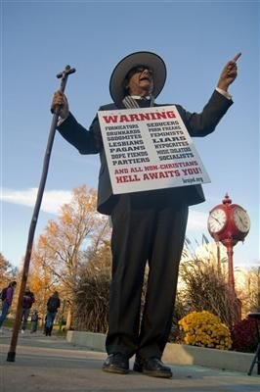
Photo From IU Newspaper
“Behold, the lamb of God who takes away the sin of the world,” I proclaimed, as I lifted high the Crucifix. “Christ came not to merely forgive our sins; but to remove our sins as far as the East is from the West. Many want their sins forgiven, while they cling desperately to their sins. But men cannot have their sins and salvation too. For salvation is salvation from sin, not merely the consequences of sin. Cling to the Cross for the forgiveness of sins and for the deliverance from the power and dominion of sin. Or you will die in your sins and be separated from God and all that is good forever and ever.”
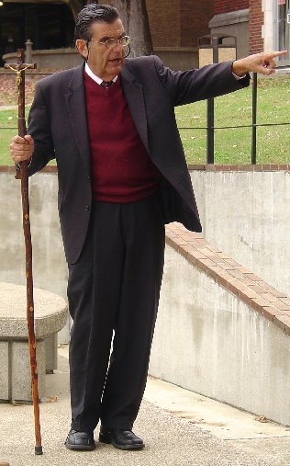
With hundreds passing by on each of the four sidewalks within hearing distance, it did not take long to gather a sizable crowd. For the first few hours the students were amazingly subdued, attentive and pensive. For the first hour I taught with few interrupting questions. Gradually, the students became more stirred and questioning; but still not hostile. However, as the day progressed I noticed a steady hardening of hearts, especially from 4 to 7 PM. For the last hour I was down to about 20 people, interestingly they were all men.
It was dark by the time I wrapped things up. IU is one of my favorite campuses to preach upon. The campus has one of the largest class breaks of any where I have ministered. It is usually a relatively easy place to gather and hold a crowd.
I am prone to nostalgia so preaching at IU relieves this distressing condition. I have so many fond memories of past preaching assignments, coming here regularly in the 70’s and 80’s with Max Lynch and Cindy before we were married. IU was the first campus I preached upon. I spoke from the steps of the Student Union in 1974; and I have not stopped or looked back since. Finally, there are the memories of my wasted years as a student at IU which trouble me. I feel in a sense that I am atoning for my many sins when preaching at IU and Indiana State.
How better things could have been if I had known the Lord during my undergraduate years! If I had only taken a stand for righteousness in my youth, what a difference it could have made for the good of others, for my own good and for the good of our blessed Lord.
NO EXCUSES
Indiana University, November 5, 2009
I had another glorious day at IU. As I was reading my Bible while waiting for the class break, a Christian introduced himself who liked my approach. He explained how his Campus Crusade friends did not like my style of evangelism. He had recently left Crusade. Meanwhile, another supportive student had questions for me. A few others gathered and listened to the conversation.
When I lifted up my voice, the crowd quickly gathered. Like the last two days, students were initially subdued and attentive; but as the afternoon progressed they became more stirred and agitated.
Late in the afternoon a modest girl walked out of the crowd shook my hand and profusely thanked me for coming. She expressed the hope of having the courage to stand up for the faith as I had been doing.
As I reflect on the day, I am convinced that what shakes up the students more than anything I teach is individual responsibility. Today one boy claimed to be a gay Christian filled with the Holy Spirit, who had been through both Teen Challenge and Exodus programs; but he claimed as hard as he had tried he could not overcome homosexuality. I gave him various promises in the Bible which teach we can overcome sin, especially through the new birth and the power of the Holy Spirit. I also spoke of will power. But he excused his homosexuality because he had been molested as a child.
One student referred to the Diagnostic and Statistical Manuel of Mental Disorders (DSM) explaining to me that there were manias which resulted in people not being responsible. I continued to impress upon the crowd individual responsibility. There may be mitigating circumstances; but there will be no excuses on Judgment Day for sinful behavior.
I have been watching the talking heads on Cable T.V. proposing that Major Moslem, who murdered 13 and wounded 30 at Ft. Hood, may have been a victim of Post-Traumatic Stress Disorder (PTSD), but indirectly, as a result the stress of having been a psychiatrist counseling returning soldiers from war. I suppose next they will come up with Pre-Traumatic Stress Disorder. Major Moslem may be excused because he was allegedly harassed for his religion and feared being deployed to the War Zone.
Of course, none of the talking heads suggested he might have been motivated by his religious beliefs or analyzing whether he is a terrorist. Despite what the General at Ft. Hood said, the evidence (as least the initial reports we have heard) does suggest that this was an act of terror and not a tragedy as the General stated at the press conference. This was a murderous massacre. I am disturbed that a soldier would not call it what it is.
In my life time there has been a proliferation of mental disorders, which have become excuses for sinful, evil and criminal behavior. The one I hear most about on campus is students who claim they are bi-polar. If they are not going to get saved, I tell them to get a grip.
I dismissed the students with prayer shortly after 5 PM. I could have easily stayed later as I have the other two days; but I wanted to drive to Terre Haute this evening. A few students helped me look for my chair which someone stole; but we were not successful in finding it. Two boys followed me back to the car. One of them wanted to recruit me to work in Obama’s next campaign. I gave the student a simple lesson in economics.
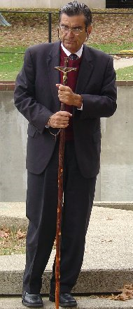
GIVEN OVER TO A REPROBATE MIND?
Indiana State University, November 6, 2009
As soon as I held up my YOU DESERVE HELL sign a student stopped to ask, “Why do I deserve Hell?” Within minutes others stopped to listen to our conversation. The questioner left, saying he would be back later.
I lifted up my voice to sound the trumpet. I gathered a crowd of 25. Eventually, a fellow with a “Free Hugs” sign started moving through the crowd hugging people. He wanted to hug me; but, of course, as always, I refused. Soon others carried handmade “Free Hugs” signs. Walter, who is one of my regulars at ISU, joined the group. Soon many were joining in group hugs; and they were marching around the plaza childishly chanting “free hugs.”
Eric, the gay blade whom I mentioned from my Monday visit to ISU, came out dressed in drag with a black wig, lip stick, wearing lingerie. He/she looked authentic strutting around in high black boots with high heels. He embraced many students and I noticed some were touching him in a sexual way. The scene became frenzied so I sat in my chair and waited for things to settle down. Meanwhile, a few students gathered to ask serious questions. Eventually, Eric/Erica sat down beside me to defend his actions claiming he feared that the students might have become too angry if he had not come out to introduce a lighter element to the scene. I did not buy his excuse for his posing as a drag queen. Eric craves attention.
I quietly informed Eric that he needed to be careful. I feared that he might be given over to a reprobate mind if he did not soon reconsider his ways. A man can go so far into sin that he reaches a point of no return, and then even God can no longer reach him. Eric seemed to be pondering my word to him. He made no rebuttal.

Eric, the Drag Queen at ISU
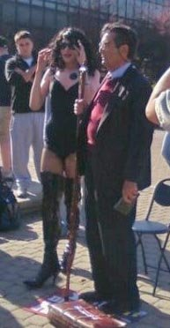

After about 30 minutes of parading the huggers grew weary, as I suspected they would; and they gathered around me once again. The last hour I had attentive listeners with thoughtful questions. I was able to expound on the true nature of love. An atheist asked, “If love is not easily provoked explain God’s judgments of the Old Testament?”
I took the opportunity to give a brief overview of God’s longsuffering with man through the time of Noah and his dealings with Israel in the wilderness and in Canaan. I read with commentary 1 Cor. 13.
In response to a column against me, I submitted the following letter to the editor of The Statesman newspaper:
In his Statesman column Harold Bosstick sites James 4:10-12 to support his claim that “men are not to judge one another.” But his article is devoted to judging me. He claims that I negate Christian beliefs with my “unloving” methods, that I have a “judgmental attitude,” that I lack mercy, and that I am an untrue “representative of God.” Mr. Bosstick teaches men are not to judge; but he judges me and my “cohorts.” What do we call a man, who does not practice what he preaches?
On the other hand I believe we should judge right from wrong, and truth from error. Jesus said, “Beware of false prophets (Matt 7:15).” How can we identify a false messenger, if we do not judge?
St. James says, “Speak not evil of one another.” This is an admonition against slander and defamation of a brother. Mr. Bosstick falsely reports that in August, 2008, I expressed to a Statesman reporter “a desire to kill homosexuals.” I checked The Statesman archives of articles from August 22 and 25, 2008, no such statement is found. My mission is to save homosexuals and other sinners from sin and Hell through the Gospel. I have no desire to kill homosexuals, nor did I express such a desire. My associate Mitch Metzger was quoted by Mark Richter as saying that homosexuals are worthy of death, which Romans 1:32 affirms. However, Mr. Metzger went on to say he opposes the death penalty for sodomy.
Mr. Bosstick points out that Jesus did not condemn the woman caught in adultery. But this woman did not attempt to justify her sin or claim that she had a right to be adulterous. Repeatedly, as I preach many ISU students justify and encourage fornication, pornography, and sodomy. Jesus did tell the adulteress to, “Go, and sin no more (John 8:11).”
The Statesmen (Nov. 6) carried a front page picture of students marching for equality and for “gay rights,” which was in response to my mission two days before. These marchers were doing the very thing that St. James writes against; they were “speaking evil of the law and judging the law,” which clearly condemns homosexuality and fornication (1 Cor. 6:9-10). Many ISU students claim as rights, what the Scriptures condemn.
The Bible condemns hypocritical judgments and judging according to standards contrary to God’s Word. Jesus Christ is the final Judge (John 5:27). My preaching is only a warning of “the wrath to come;” and my message should be judged in the light of the Bible.
Jed Smock, B.S., ISU, ‘65; M.S. , ISU, ‘67

Martha at Morehead State in Kentucky

What can you do to help?
1. We need faithful prayer warriors to intercede for souls as well as praying for our health, safety and financial needs. This is vital!
2. As always, we need monetary gifts. We appreciate that some of your budgets are considerably tighter and yet you have continued to give faithfully. May God reward your generosity. Some have had to reduce your giving significantly, but you are still donating what you can. Thank you also. Please know that no gift is ever too small. God accepts them and so do we. If more of you would just send small gifts, it would help us greatly. If any of you do have extra funds and can make up the slack, please do so. We are also trying to find ways to reduce our own budgets. Often saints provide lodging for us when we come to their campus town. If you would like to help in this important way please contact us.
3. Arranging a church or home meeting is a great way to bless the CMUSA. Bro. Jed welcomes the opportunity to meet and minster to new people. He is thankful to address groups both large and small. It is amazing the hearts that God will touch in just a small home meeting. I believe that there are many Christians who would like to support this work on the campuses if they knew about it. Help us get the word out.
4. Finally, invite your friends to receive this journal also. It will make Christianity come alive, increase their faith and keep them revived!
5. Also, if you haven’t read Who Will Rise Up? lately, I encourage you to do so. If you gave your copy to someone and never got it back, you may order a new one from us for a $12 gift to CMUSA. We found a few extra boxes.
You may donate to CMUSA using PayPal by going to our website at Brojed.org or you mail mail a check to our home office: CMUSA, Bro. Jed smock, 2402 Longview Dr. Columbia, MO 65203

